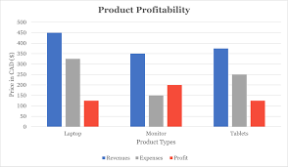  
  
  
  
What is computer game addiction?  
 Computer game addiction generally refers to an excessive, unhealthy amount of playing computer games. Rather than engaging in the real world, an addicted user devotes the majority of his or her time to gaming. The addicted gamer often isolates him/herself from others, ignores more important responsibilities, and is often obsessed with obtaining higher status / rankings / achievements in his/her favorite computer game.  
  
  
   
  
  
  
  
  
  
  
  
  
  
  
Video game addiction is a compulsive mental health disorder that can cause severe damage in one’s life. It’s common for a video game addict to spend over 10 hours a day gaming, usually well into the night, and many suffer from sleep deprivation. Immersed in their experience, gamers are known to have poor diets consisting mainly of energy drinks full of caffeine and sugar. Many are dehydrated and malnourished.  
  
  
In more severe cases, gaming addicts report agoraphobia – a type of anxiety disorder in which they fear leaving the house – and others identify with hikikomori — a term popularized in Japan as reclusive adolescents or adults who withdraw from social life  
  
  
  
Gaming addicts tend to be moody and irritable, depressed, physically aggressive, and refuse to go to school or work due to gaming. To be a gaming addict is to experience functional impairment in multiple areas of your life, and the long-term effects can be devastating. Gaming addicts fail out of college. They get divorced. And they struggle with unemployment.

NAME : MUHAMMAD SAMI ULLAH………………………………  
FATHER NAME : AHSAN ULLAH……………………………  
PHONE NO. :03278278707…………………………

EFFECT OF COMPUTER GAME ADDICTION

Computer Game Addiction